**Mayur Jagtap**

**Senior software engineer**

**Docker compose of Voting python-Java-Node-JS application**

* Create Ubuntu 16.04 Server – 8 GB RAM
* Install Docker on server 🡪

**sudo apt-get install apt-transport-https ca-certificates curl software-properties-common**

**curl -fsSL https://download.docker.com/linux/ubuntu/gpg | sudo apt-key add –**

**sudo apt-key fingerprint 0EBFCD88**

**sudo add-apt-repository "deb [arch=amd64] https://download.docker.com/linux/ubuntu $(lsb_release -cs) stable"**

**sudo apt-get update**

**sudo apt-get install docker-ce**

* Install Docker Compose on Server 🡪

**curl -L https://github.com/docker/compose/releases/download/1.11.2/docker-compose-Linux-x86_64 -o /usr/local/bin/docker-compose''**

**sudo chmod +x /usr/local/bin/docker-compose**

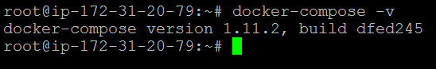

* Now Copy the source code to directory /OPT/ of python application from GITHub 🡪

**Cd /opt/dockerdemo**

**git clone https://github.com/maheshkharwadkar/example-voting-app**

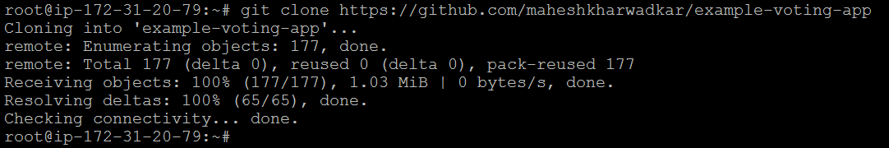

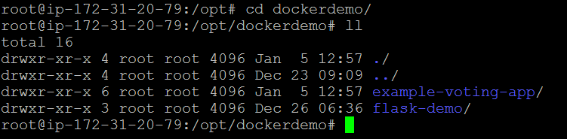

* Now Compose the build 🡪

**cd example-voting-app/**

**docker-compose build**

* It will build the image for an application as per instructed in shell script in "docker-compose.yml” file.



* Docker-Compose.yml file built the necessary images and services, network, define ports, links & other dependencies like maven plugins to build the .jar file for application and finally create docker images & containers for the application.



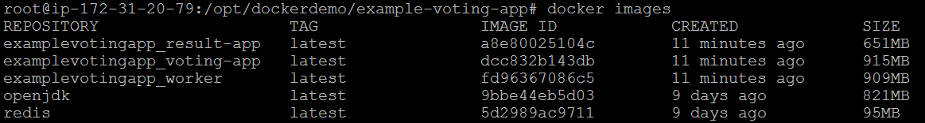

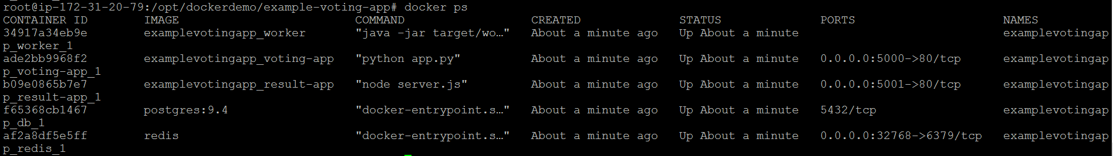

* Now RUN the container at same time 🡪 It will pull the images as instructed and if it is not available it will pull from docker hub and RUN the containers.

**docker-compose up -d**

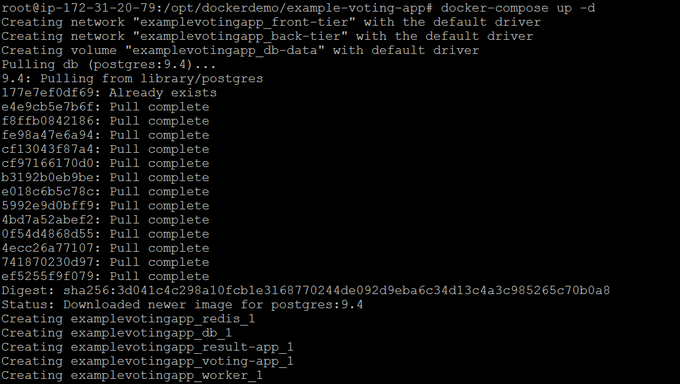

* Now hit the public IP at 5000 port to open the Voting application 🡪

(We have assigned PORT 5000 to Voting Application in **.yml** file)

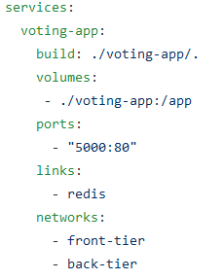

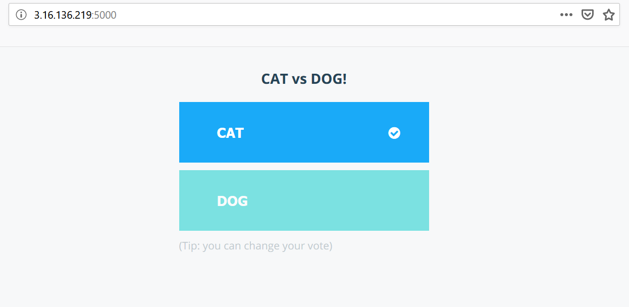

One vote will be considered only from one IP i.e. One person can vote only one candidate.

* Now hit the public IP at 5001 port to open the Result Application 🡪

(We have assigned PORT 5001 to Voting Application in **.yml** file)

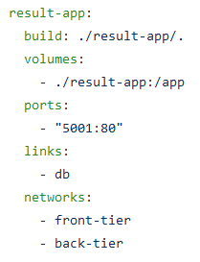

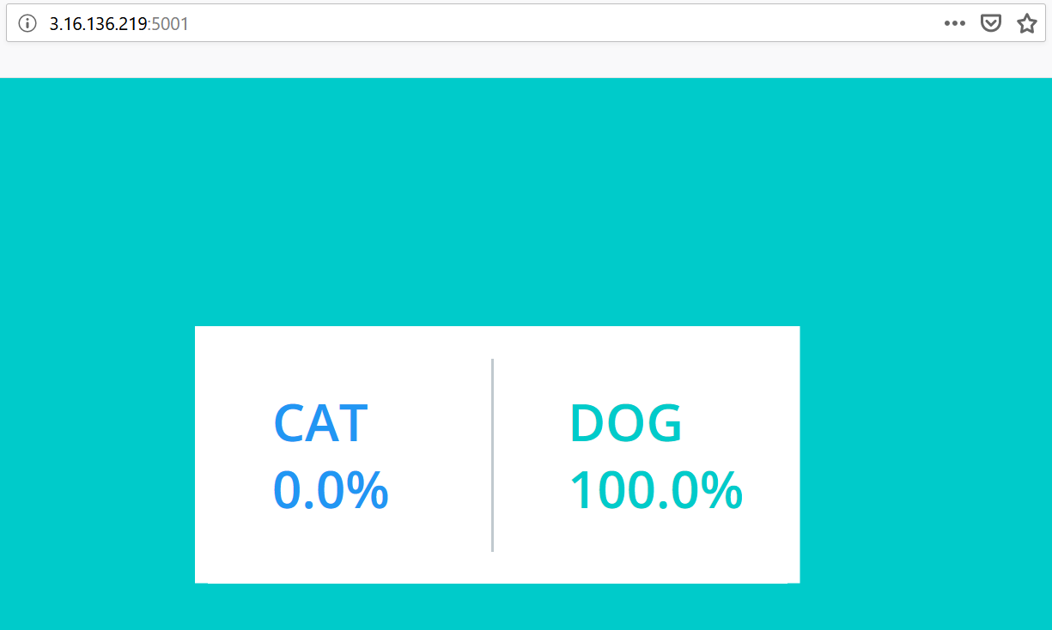

* To stop the running compose container 🡪

**docker-compose stop**

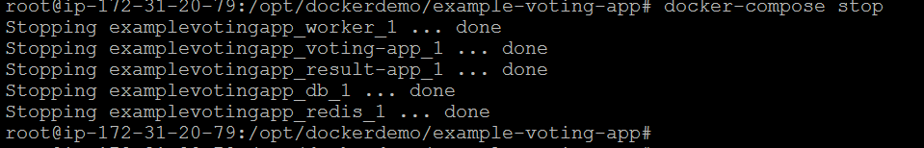

* Delete the Front & Back Tier network which is created for the application 🡪

**docker network rm examplevotingapp_front-tier**

**docker network rm examplevotingapp_back-tier**



* To delete the volume created by application 🡪

**docker-compose down –volumes**

